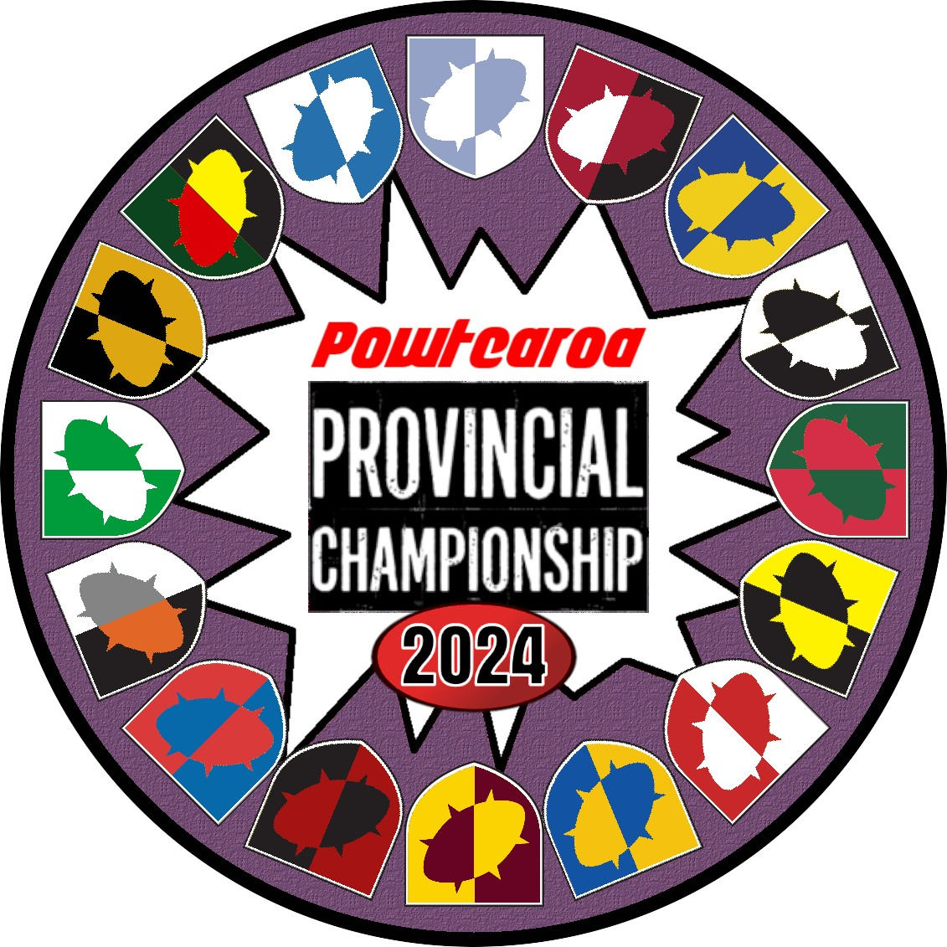
Players Pack

1.0 General Information
WHEN: November 2nd & 3rd
WHERE: The Cashmere Club, 50 Colombo Street, Cashmere, Christchurch 8022
SCHEDULE:
Day 1 | Saturday 2 Nov. | Day 2 | Sunday 3 Nov.
Registration | 9.00 am | Doors Open | 9.00 am
First Round | 9:30am – 11:45am | Fourth Round | 9:15am – 11:30am
Lunch | 11:45am | Fifth Round | 11:30am – 1:45pm
Second Round | 12:15pm – 2:30pm | Lunch | 1:45pm
Third Round | 2:30pm – 4:45pm | Prize Giving | 2.15pm
Finish | 4:45pm | Finish | 2:45pm

TICKET PRICE:
All attendees must be registered for the NAF, so that all games at the event can be recorded in the international Blood Bowl tournament tracking system.
Standard ticket price $40
NAF registration $10 (mandatory for coaches with no previous NAF registration)

Please contact Jesse Callaghan (j.callaghannz@gmail.com) to arrange payment.

TOURNAMENT OFFICIALS:
The main Tournament Organiser (TO) for the event Jesse Callaghan. Please email at j.callaghannz@gmail.com if you have any enquiries.

VENUE FACILITIES:
Food and drink options are available through the venue. Please do not bring food or drink from outside into the venue. The Bar will be open from 12 for the duration of the tournament, with onsite food available.

What to bring:
To successfully navigate your way to the end of the tournament you will need to bring along:
- Your painted Blood Bowl team, completed to a minimum of three colours on each miniature and all models clearly numbered and easily recognisable as appropriate models for their race and position (non-GW models may be used)
- Miniatures must be clearly numbered to correspond with team roster sheets. As part of this, all players must be uniquely (and obviously) numbered to correspond with team roster sheets. The only exception to this is to appropriate Star Player models!
- Three (legible!) copies of your Team Roster
- If you can - one Blood Bowl Pitch & dugouts, plus all accompanying templates. Pitches with squares of 32mm (4th edition) or larger are preferred.
- If you can - one set of three GW or NAF Block Dice, two six-sided dice with pips (not numbers) (2D6), an eight-sided dice (D8), and a 16 sided dice (D16).
- A 2020 rulebook and copy of this players pack if you have them.

At the end of each game the competitors are required to record their match result, registering both teams’ touchdowns and team casualties (caused by whatever means – crowds, weapons, blocks, failed dodges, etc).

2.0 Provincial Squad Rules
General:
The Powtearoa Provincial Championship is a team tournament, intended to determine which NZ Blood Bowl Province is the best in 2024.
The following rules apply to Provincial Squad Creation:
- Coaches at the event must compete as part of a squad of four. Each squad must represent a NZ Blood Bowl Province. Preference will be given to complete representative teams, but any individual NAF Member is welcome to register and will be allocated to a team (space permitting).
- Each NZ Blood Bowl Province is limited to ONE provincial squad. Provinces may not overlap geographically, but neighbouring provinces may combine (e.g. Otago & Southland).
- There is an expected venue limit of 40 coaches (10 teams) and priority will be given to representative squads from regions with established Blood Bowl leagues and/or who hold their own annual NAF tournaments. These are (North to South): Auckland, Bay of Plenty, Hawke’s Bay, Manawatu, Kāpiti, Wellington, Marlborough, Canterbury, Otago
- Invitations will be sent to the Tournament Organisers / League Commissioners to nominate a Squad Captain and agree the selection criteria for their Squad. Other NZ provinces may apply for entry to the tournament provided they are able to produce 2 or more representative players including an elected Squad Captain.
- In all cases it is expected that the selection criteria will be fair and open, and at least some slots per team should be made available for qualification based on best performance(s) at NAF tournament(s) in 2023/24.
- Should a Squad Captain be unable to find four representative coaches from their province for their squad they can recruit from the pool of individual applicants after the deadline close. Provinces containing outsiders should have a descriptor (e.g. Marlborough Marauders instead of simply Marlborough).
- Applications for Squads and Individuals are open. Applications for Individuals close 31 July and for Squads 31 August.
- Individuals applying to join the tournament will be assigned either to a Provincial Squad or Barbarian Squad, with a preference offered to coaches from provinces not represented already. Excess applications beyond the venue limit will go onto a waitlist in order of application.
3.0 Matchups and Scoring
Matchup Selection
Coaches will initially be ranked within their squad based on global NAF ranking (https://www.bloodbowl.dk/coach-rating/ ). In the case of tied ranking, the higher tiered race will be ranked higher. If still tied, ranking will be random.
For Round 1, this ranking will be used to assign matchups highest to lowest. (i.e. top ranked coaches of the opposing squads will play each other).
After each round the ranking within each squad will be reassigned based on coach standings on the individual points table.
NOTE: As for all Tabletop tournaments Coaching during a match is strictly prohibited. You can tell a squad mate if he needs a win, draw or loss. But no other advice is allowed.
Squad Scoring:
- WIN: 2 points (you win more matches than the opposition)
- DRAW: 1 point
- LOSS: 0 points
Squad Tiebreakers: After the 5 rounds the Squad with the highest squad points will be declared Best Province. In a tied situation the tie breaker will be determined (in order) by: Combined Individual points; Opposition squad points (i.e. strength of schedule); Opposition combined individual points; Net TD; Net Cas; Captain arm wrestle.
Individual Scoring:
- WIN: 4 points
- DRAW: 2 points
- LOSS BY ONE TD: 1 point
- LOSS BY MORE THAN ONE TD: 0 points
- CONCESSION: Minus 2 points (deemed a 3-0 win for opposition in both TD and CAS).
Individual Tiebreakers: Opponent score (i.e. strength of schedule)*; Net TD; Net Cas; TD for; Cas for; Random
* note – for ranking match-ups throughout the tournament Opponent Score will not be used as a tiebreaker
4.0 Roster Creation
Budget: All coaches will receive a Team Draft Budget of 1,150,000 gold pieces to spend on roster creation.
Squad Limits: Each coach selected for a squad must use a different team/race than their squad mates. Squads cannot contain multiples of a race. You cannot hire the same star player more than once in the teams that are part of a squad.
Teams: Coaches must choose their team from the following sources:
- Blood Bowl Second Edition – The Official Rules, plus
- a. Spike! Magazine #13 (Khorne)
- b. Spike! Magazine #14 (Norse)
- c. Spike! Magazine #15 (Amazon) d. Spike! Magazine #16 (Vampire)
- e. 2022 Almanac
2. Official “Teams of Legend” PDF (excluding Norse, Amazon and Vampire)
3. The NAF “Rules for Tournaments from 1st January 2022” pdf (Slann)
NOTE: GW Nov 23 FAQ/Errata are in effect. This tournament does not include any rules or inducements from Blood Bowl Death Zone rules. Any further errata or team releases may be included at the discretion of the TO up until 6 weeks before the tournament. Any changes will be advised by the TO to the respective captains
Inducements: You may spend money on any inducements included in The Official Rules, and these become part of your permanent roster. No Wizards and/or Mercenaries of any kind can be purchased.
4.1 Tiers
Tiers and Skill packages.
Teams are separated in five different tiers and offered different skill sets to choose from. Your team may select one of the skill packages available for teams of that tier.
Each team is permitted to stack 2 Primary Skills on a maximum of 1 player at the cost of both 1 Primary Skill and 1 Secondary Skill. If your team and skill set do not allow you to give Secondary Skills to your players, you’re not allowed to stack skills.

Tier 1: Chaos Dwarves, Dark Elves, Dwarves, Lizardmen, Orcs, Undead, Underworld, Wood Elves.
- 6 Primary Skills
- 4 Primary Skills + 1 Secondary Skill
- 3 Primary Skills + Access to 1 Star player
Tier 2: Amazon, Elven Union, High Elves, Humans, Necromantic Horror, Norse, Skaven, Slann, Vampires.
- 7 Primary Skills
- 5 Primary Skills + 1 Secondary Skill
- 4 Primary Skills + Access to 1 Star player
Tier 3: Black Orcs, Chaos Chosen, Imperial Nobility, Khorne, Nurgle, Tomb Kings,.
- 7 Primary Skills + 1 Secondary Skill
- 5 Primary Skills + 2 Secondary Skills
- 5 Primary Skills + Access to 1 Star player

Tier 4: Chaos Renegades, Old World Alliance, Snotlings.
- 8 Primary Skills + 1 Secondary Skill
- 6 Primary Skills + 2 Secondary Skills
- 6 Primary Skills + Access to 1 Star player
Tier 5: Halflings, Goblins, Ogres.
- 8 Primary Skills + 2 Secondary Skills
- 6 Primary Skills + 3 Secondary Skills
- 6 Primary Skills + Access to 1 Star player
- 4 Primary Skills + Access to 2 Star players

Star Players
The following star players will incur an additional cost to those wishing to employ their services. The skill cost listed below will be deducted from the skill set selected by the coach.

Star Player | Skill Cost
Morg’N’Thorg | 3 Primary Skills
Hakflem Skuttlespike | 3 Primary Skills
Deeproot Strongbranch | 2 Primary Skills
Griff Oberwald | 2 Primary Skills
Kreek Rustgouger | 2 Primary Skills
Bomber Dribblesnot | 2 Primary Skills
Skitter Stab Stab | 2 Primary Skill
Varag Ghoulchewer | 1 Primary Skill
Cindy Piewhistle | 1 Primary Skill
Wilhelm Chaney | 1 Primary Skill

5.0 Prizes
The following achievements will be awarded prizes. As is usual for NZ tournaments there will be a highlander rule in effect (i.e. “there can only be one!”) so nobody will get more than one prize.
For example, if the best individual is in a top-2 squad, the Individual Champion prize (but not title) will go to the highest ranked player from the remaining squads.
- Champion Squad (Trophy and prizes for each squad member)
- Runner-Up Squad (Prizes for each squad member)
- Individual Champion
- Individual Most Casualties
- Individual Most Touchdowns
- Individual Best Painted
- Individual Best Sport (as voted by other attendees at the event)
- Individual Stunty King* (only if there are more than one stunty teams)
There also will be commemorative swag for all attendees.

