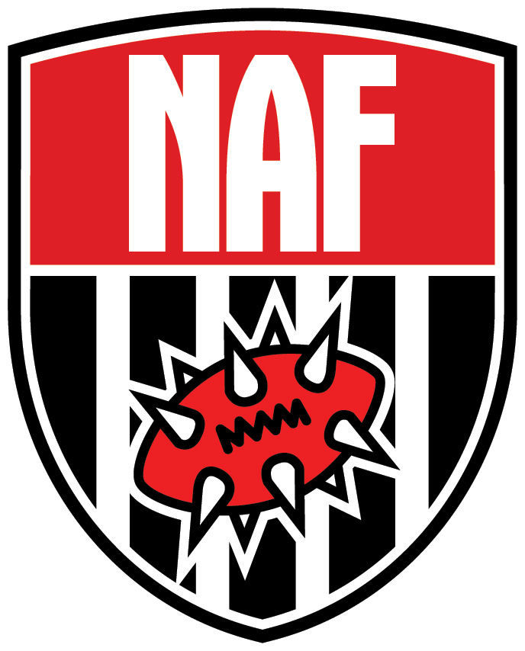

PROPOSED CHANGES TO NAF
APPROVED CHARTER
December 20th, 2004

Rationale for Adoption
Since the NAF was founded we have been continually learning about what it takes to run an organization like ours. In the last year the President and his advisors have been reviewing our procedures and have determined we need to change and add certain positions to ensure the NAF can live up to its mandate. The President feels these changes are necessary to meet the needs of the ever-expanding needs of our members.

Summary
The NAF needs to reorganize some positions to ensure we are giving the best support to tournaments around the world. At the moment the NAF does not have enough people in various areas of the world to meet the needs of members who are organizing tournaments.

The Senior National Tournament Organizer has been renamed to Tournament Director and made an elected position. The Tournament Director’s main role will be to ensure that approvals and tournament results happen in a timely manner. The Tournament Director will be assisted by a roster of Regional Tournament Coordinators that will act as his “eyes and ears” around the world. Currently these people are known as NTOs. These people typically are in charge of a certain region, but we believe we need to add more people to properly administrate large area (such as the UK, France, etc.). Tournament Coordinators will still be assigned to a certain region but there will often be more than one in areas that need it. The recently-elected Tournament Director is Cris Schmitt (Sputnik), based in Germany. It is the responsibility of the Tournament Director to appoint and maintain a cadre of Regional Tournament Co-ordinators (RTCs).

We have also promoted the Membership Organizer position to Membership Director in the Administrative Level. In our experience the Membership Organizer has been a key role in administering NAF activities. This will remain an appointed position.

We have added a new specialized Level position known as Content Editor. This person ensures the day-to-day operations of the NAF website run smoothly by approving news, maintaining the FAQ, moderating forums, etc. This is an appointed position.

Article I has been reworded slightly to more accurately reflect the NAF’s activities by adding the words “tournament/league support”.

Resolution
BE IT RESOLVED, by the NAF Administrative Level Officers, that:

Article I is changed to read:

The NAF is an international association of Blood Bowl players dedicated to the game of Blood Bowl. The NAF’s goal is to help grow interest in the game of Blood Bowl and act as a central resource for Blood Bowl coaches the world over – offering news, contacts, discussion, game demonstrations, sanctioned tournaments, international player rankings, and tournament/league support.

Article III is changed to read:

The NAF is arranged much like a traditional organization, with specialization in certain areas to meet the needs of an international club. Officer positions within the club are divided into two groups: Administration Level and Specialized Level. The Administration Level consists of the traditional club positions: President, Vice-President, Treasurer, Membership Director, and Tournament Director. Specialized Officer Positions are those that have been created at the behest of the Club President to enhance and/or fulfill a specific need within the club's officer program. However, unlike the Administrative Level positions, Specialized Officer Positions do not require an amendment of the Club Charter, and shall not be permanent in the sense that they can be removed at the behest of the Club President if no longer needed. Specialized Officer Positions are: Tournament Coordinator, Webmaster, and Content Editor.

Administrative Level Officer Positions:

President (Elected Position)
- Directs NAF strategy and planning
- Chairs meetings
- Serves as liaison between members and officers
- Serves as liaison between outside organization and NAF
- Fulfills duties of other officers if absent from meetings or events
- Reviews regular reports from other officers and offers direction
- Sets meeting agenda items

Vice-President (Appointed Position)
- Assumes leadership if president resigns or is unavailable
- Advises on NAF strategy and planning
- Presides over meetings in president's absence
- Fulfills duties of other officers if absent from meetings or events
- Assists President in any presidential tasks as required

Treasurer (Elected Position)
- Collects any enacted club dues
- Maintains club finances
- Keeps records of finances (for public viewing if requested)
- Advises on NAF strategy and planning

Tournament Director (Elected Position)
- Direct, appoints, and trains Regional Tournament Coordinators
- Ensures events are approved in a timely manner
- Assists Administrative Officers with planning and initializing events
- Works with Administrative Officers to publicize events to club and general public
- Any other 'specific-need' responsibility as deemed by the NAF President
- Advises on NAF strategy and planning

Membership Organizer (Appointed Position)
- Arranges printing and distribution of membership packages
- Assists Tournament Coordinators with registration at events
- Any other 'specific-need' responsibility as deemed by the NAF President
- Advises on NAF strategy and planning

Specialized Level Officer Positions:

Tournament Coordinator (Appointed Position)
- Acts as club liaison to other official event coordinators during event planning
- Assists Tournament Director with planning and initializing event(s)
- Ensures events are approved in a timely manner in their region
- Ensures tournament results are entered correctly in a timely manner
- Works with Tournament Director to publicize events to club and general public
- Any other 'specific-need' responsibility as deemed by the NAF President

Webmaster (Appointed Position)
- Administers, updates, and operates all aspects of the club website
- Assigns members and/or officers to assist with website administration
- Maintains club databases and servers
- Builds new functionality for the website as required
- Any other 'specific-need' responsibility as deemed by the NAF President

Content Editor (Appointed Position)
- Administers, updates, and operates all aspects of the club website
- Approves news, FAQ entries, moderates forums and edits submitted content
- Any other 'specific-need' responsibility as deemed by the NAF President

